# Sending Grades from Blackboard Ultra to CampusNet

It is now possible to send Mid-semester and Final grades from Blackboard Ultra into CampusNet. Though the grades can be sent from Blackboard Ultra, once imported into CampusNet, you will still have the ability to override the grades there. You may send grades from Blackboard Ultra into CampusNet as many times as you’d like prior to submitting grades in CampusNet.

The steps to send grades from Blackboard Ultra to CampusNet require you to:

* Check the Grading Schema in Blackboard Ultra
* Setup the Overall Grade column
* Setup the Overall Grade column for Mid-semester Grades
* Setup the Overall Grade column for Final Grades
* Send Grades from Blackboard Ultra
* Import Grades from Blackboard Ultra into CampusNet

The following instructions will ensure that the proper setup in Gradebook has been completed to successfully transfer grades into CampusNet.

## Check the Grading Schema in Blackboard Ultra

1. Ensure the Grade Schema in Blackboard Ultra is reflective of the one in your syllabus. The default grading schema is based on CSU’s approved Undergraduate schema. If you have a different schema or would like to look at the one currently set, go to **Gradebook > Settings (gear icon)**.

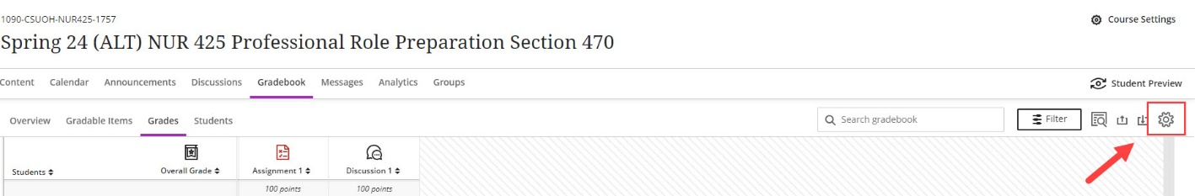

1. Click on the **Manage Grade Schemas**.

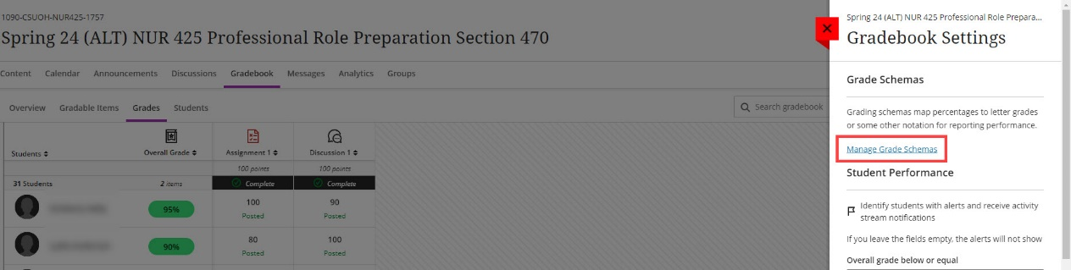

1. Ensure the **Grading Schema** matches that provided in your syllabus. Once complete, click the **X** to close. If you need assistance adjusting this area, please see [Blackboard's grading schemas help page](https://help.blackboard.com/Learn/Instructor/Ultra/Grade/Customize_Grading_Interface/Grading_Schemas), or email the Center for eLearning at [elearning@csuohio.edu](mailto:elearning@csuohio.edu?subject=Default%20Grading%20Schema%20Adjustment).

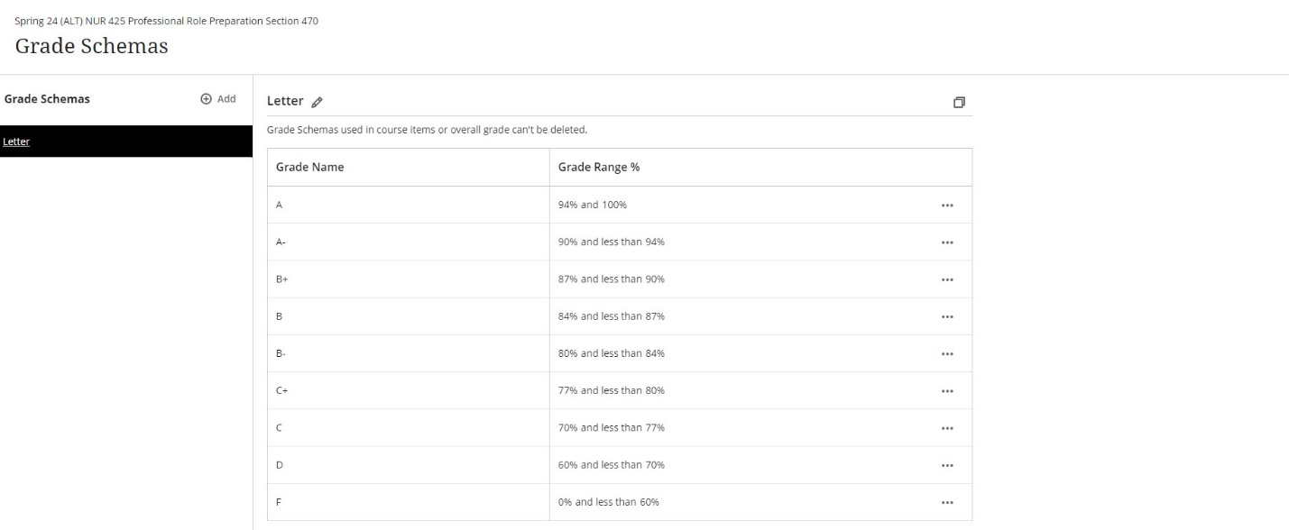

* For Graduate level courses that do not offer a C+ or D as a grade, you must delete these specific rows by clicking the three dots and selecting **Delete**. The grading scale is automatically adjusted.

* **Important Note**: If the C+ and D rows are not removed from the grading schema and a graduate student earns one of those grades, Blackboard will send it, but you will receive an error in CampusNet notifying you that these grades are not allowed. Only those grades will not import. All other grades are will successfully import.

## Setup the Overall Grade Column in Blackboard Ultra

A requirement for using Grades Journey in Blackboard Ultra is utilizing the **Overall Grade** column. If you previously dismissed the setup for Overall Grade, you will need to bring the column back into the Gradebook. If you already have the Overall Grade in your Gradebook, please skip this section. To setup **Overall Grade**:

1. While in Gradebook, click on **Settings** (gear icon) in the upper right.

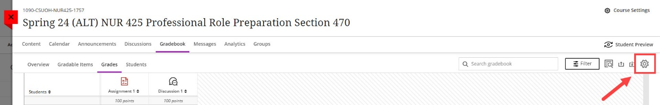

1. Under **Overall Grade**, click on the **Set up overall grade** box.

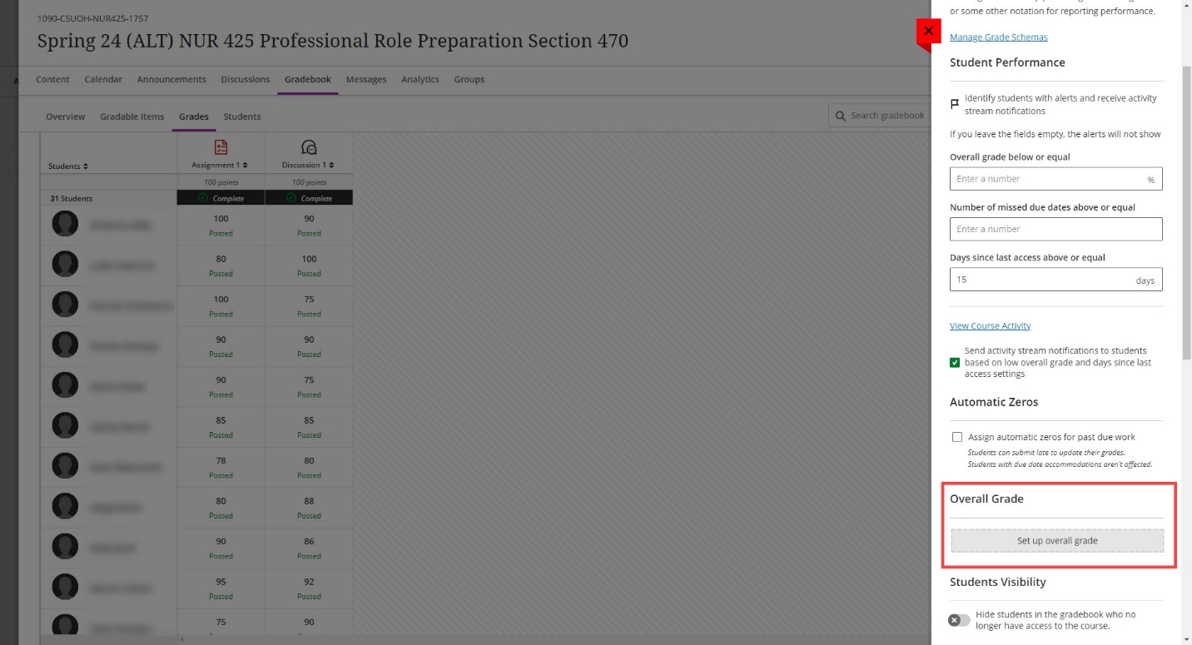

1. Blackboard will walk you through creating the overall grade based on your intended calculation (points, weighted or advanced using calculations).

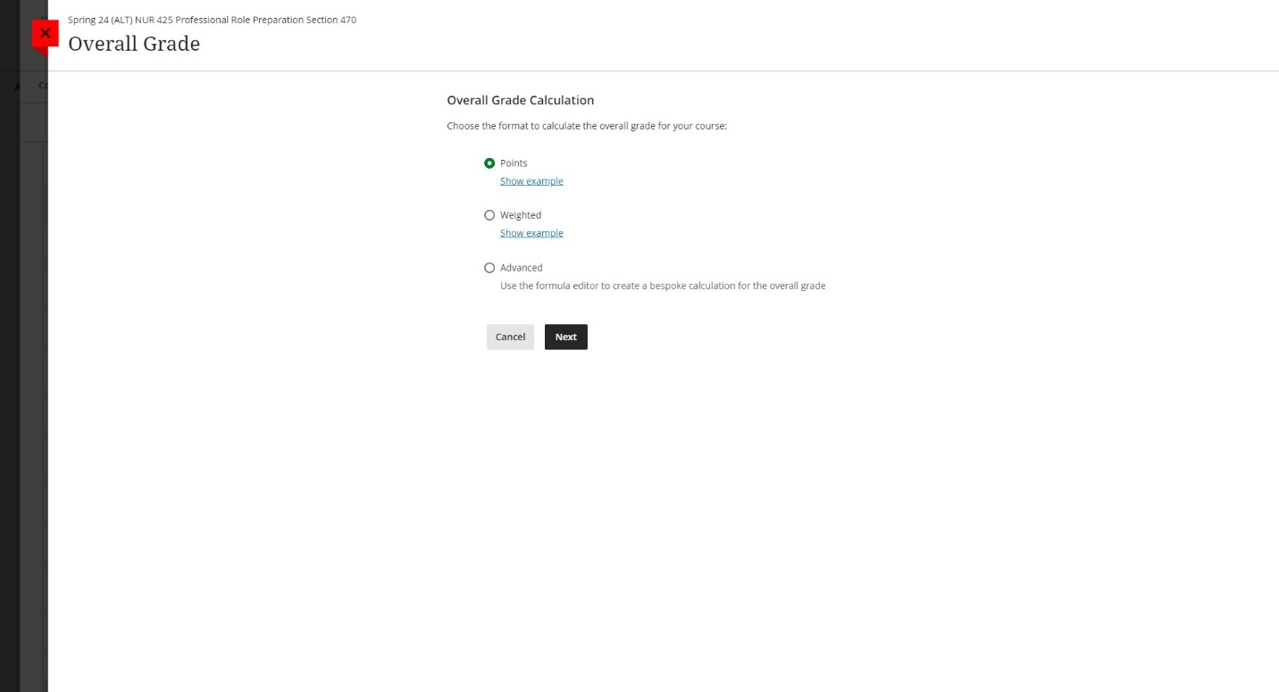

1. When creating the calculation, ensure that **Letter** is chosen from the **Select how the overall grade is displayed** dropdown. Click **Save** when finished creating the overall calculation.

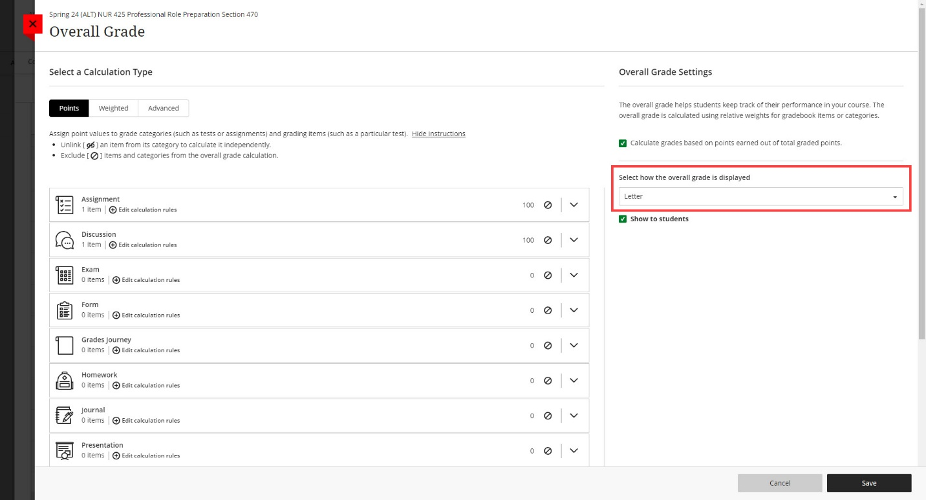

## Setup your Overall Grade Column in Blackboard Ultra for Mid-semester Grades

In Blackboard Ultra, the Total and Weighted Total columns were eliminated to create one single unified column called Overall Grade. You can setup this column to serve as a Total, Weighted Total or Advanced (calculation based). For the purposes of Grades Journey, this column is the only column that can be sent over to CampusNet. Therefore, for Mid-semester grades, it is recommended that you manually create a column in your Gradebook that will report the letter grade successfully to the Overall Grade. The creation of an extra column is not necessary for Final grades, as the Overall Grade will be reflective of student performance over the entire semester.

**CAUTION**: If you previously setup your Overall Grade to be a Total or Weighted Total, you may need to setup your gradebook calculation again after using Grades Journey. This will be dependent on if you use the Advanced calculation mentioned in this section. If your Gradebook is current and reflective of current student performance, you can skip this section and go to Import Grades from Blackboard Ultra into CampusNet.

In order to successfully send Mid-semester grades to CampusNet, the following must be done:

* Manually create a column that uses the Letter Grading Schema and is out of 100 points.
* Enter the student points out of 100 so that the Letter schema is correctly applied.
* Edit the Overall Grade and select Advanced.
  + In Advanced, click Total and choose your manually create column from the dropdown.

The following instructions outline how to complete each step.

1. Click on **Gradebook** and click on the **Grades** tab.
2. Click on the purple plus wherever you would like the Mid-semester letter grade column to go and click **Add Item**.

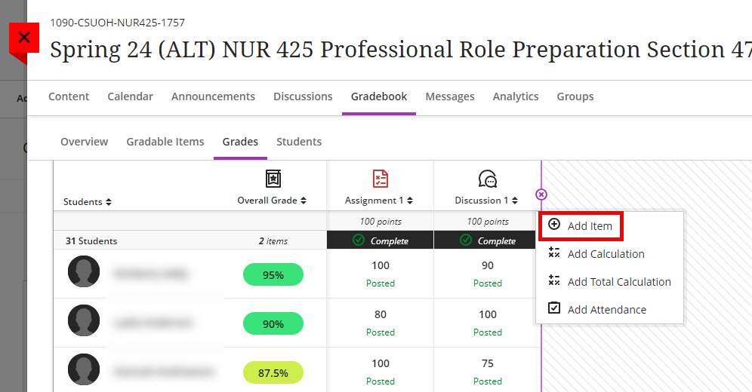

1. In the window, enter a **Name** for the column and choose **Letter** from **Grade Using**. Leave the default points out of 100. This will be the scale on which you will enter the grades based on the Letter schema. Click **Save**.
   1. Pay attention to the **Grade Category** for this manually created column. You will need to exclude it from the grade calculations in the next step.

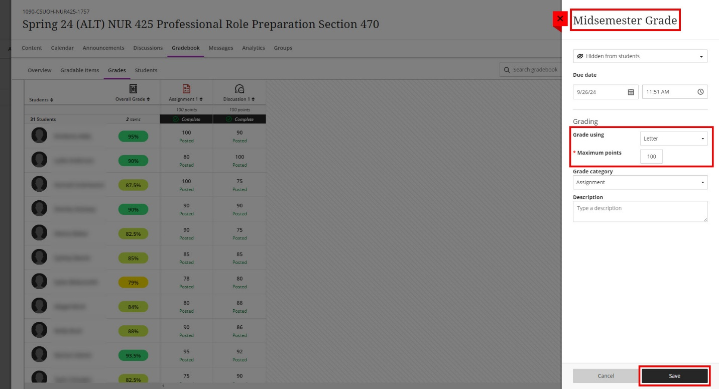

1. With the Mid-semester Grade column created, we need to exclude it from all calculations to ensure it is not adding to the points in the course. Click on the icon for **Overall Grade** and select **Edit**.

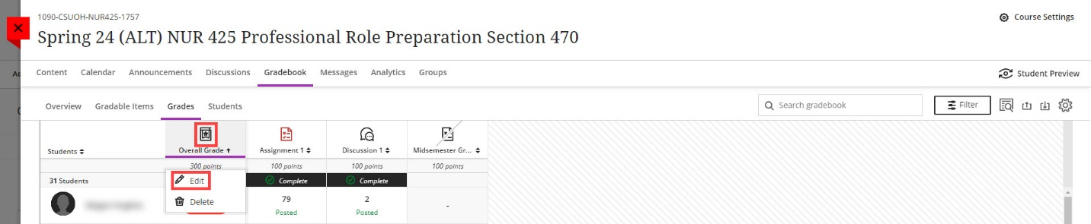

1. In the example from Step 3, the column created was added to the **Assignment** category. This needs to be excluded. To do, click on the chevron to open the Assignment items and then click on the circle with a slash through it. It will turn purple when it is excluded. Click **Save** and then the **X** to close the menu.

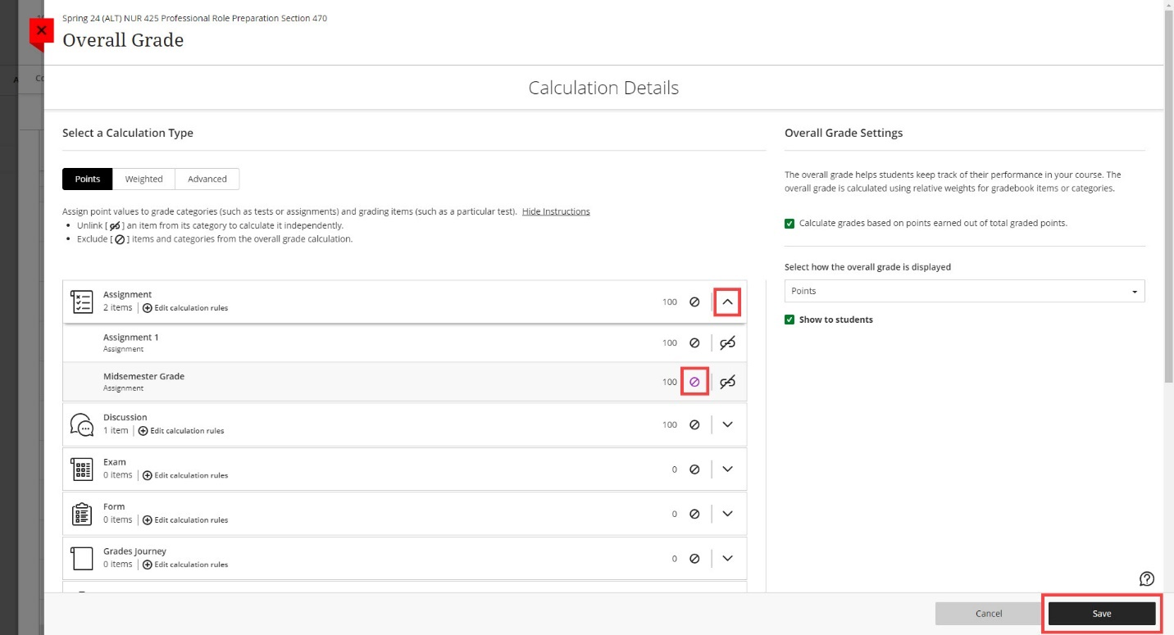

1. Click on the **Advanced** tab. We will set the **Overall Grade** to be the manually created column.
2. Click on **Total** from the **Functions and Variables** box and then choose **Mid-semester Grade** from the dropdown menu (or the column’s name that you created). Click **Save**.

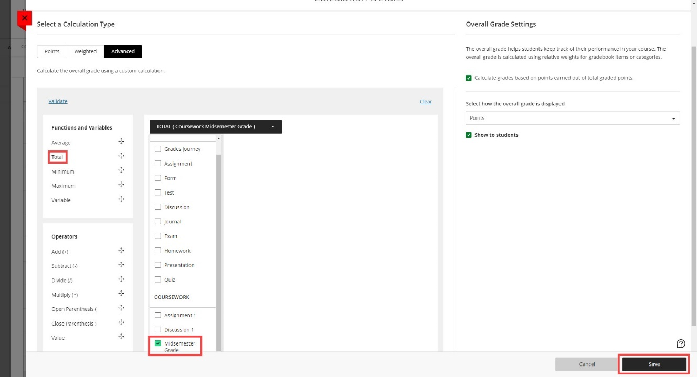

1. You are now ready to enter point values for the column that will reflect the current student performance.

## Setup the Overall Grade Column in Blackboard Ultra for Final Grades

In Blackboard Ultra, the Total and Weighted Total columns were eliminated to create one single unified column called Overall Grade. You can setup this column to serve as a Total, Weighted Total or Advanced (calculation based). For the purposes of Grades Journey, this column is the only column that can be sent over to CampusNet. For **Final** grades, this column should be finalized and reflective of student performance over the entire semester.

To confirm that the Overall Grade is ready for Final Grades:

1. Ensure all grades have been posted. You can scroll through your gradebook to ensure there are no new submissions and that all grades show as posted. You may also click on the **Overview** or **Gradable Items** tabs to ensure everything has been graded.

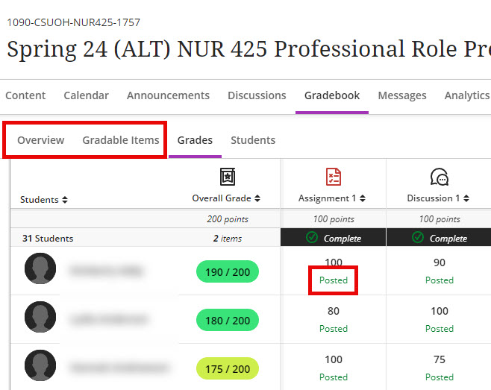

1. Ensure your Overall Grade column has been set to the **Letter** grading schema. If you are unsure of your grading schema, please refer to the Checking the Grade Schema in Blackboard Ultra section. To edit the Overall Grade column, click on the icon and select **Edit**.

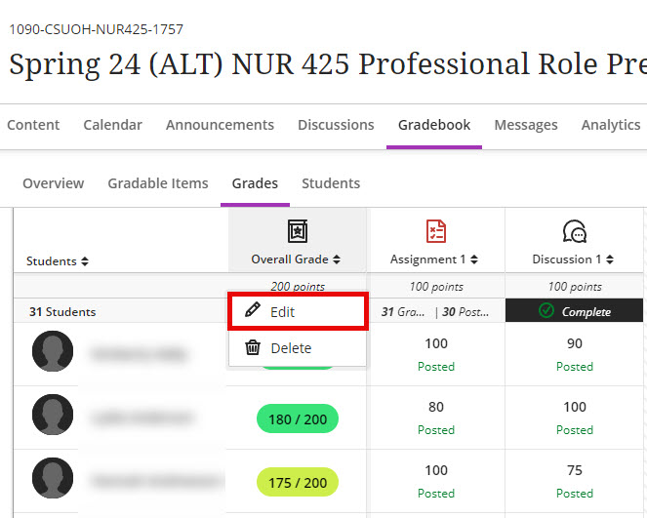

1. In the **Select how the overall grade is displayed** dropdown, choose **Letter**.
2. Click **Save** and then click the **X** to go back to the Gradebook.
3. You will see the Overall Grade column has been changed from points to a letter grade. Ensure that the student grades are accurate based on your grade schema.

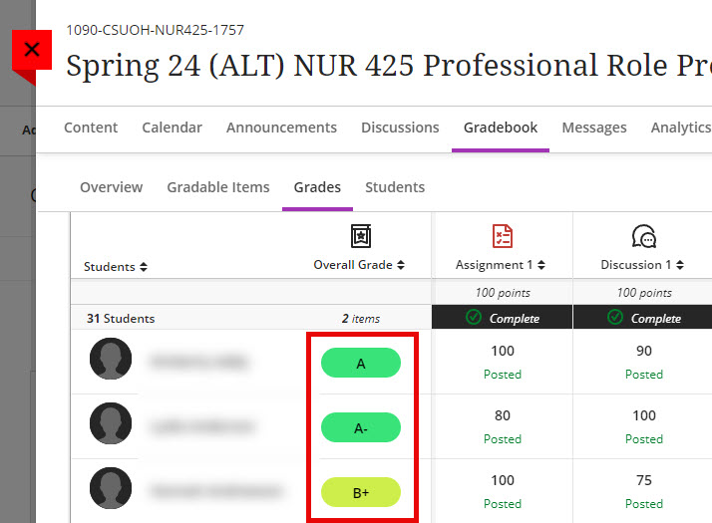

## Send Grades from Blackboard Ultra

1. With the setup complete, grades are now ready to be sent to CampusNet. To initiate the process, navigate to **Content -> View course & institution tools** under **Books & Tools**.

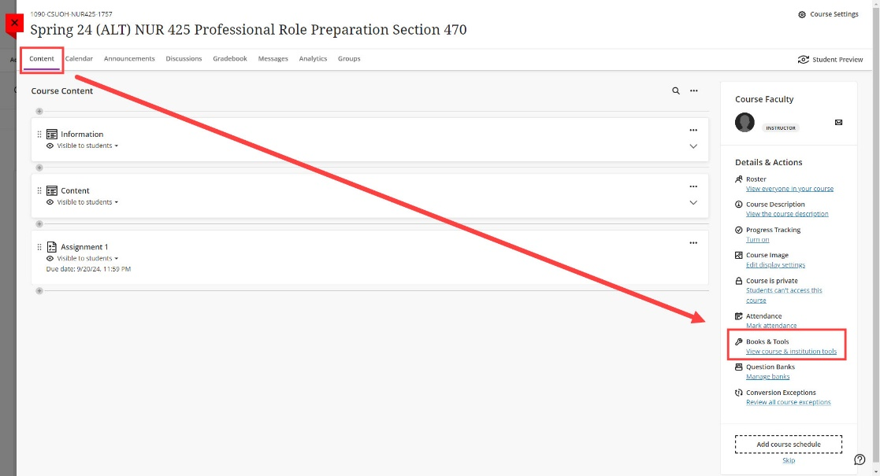

1. Choose **Grade Approval and Transfer** from the list of tools. If you do not see it populated in your list, click on **Browse all course tools** at the bottom of the menu and choose it from the alphabetical list.

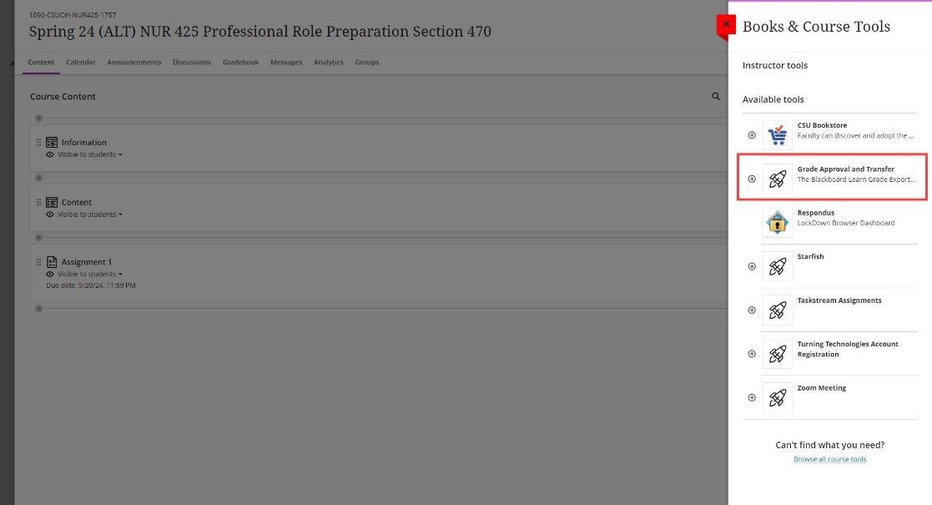

1. Check the box to the left of the Course ID and click **Extract Grades**.

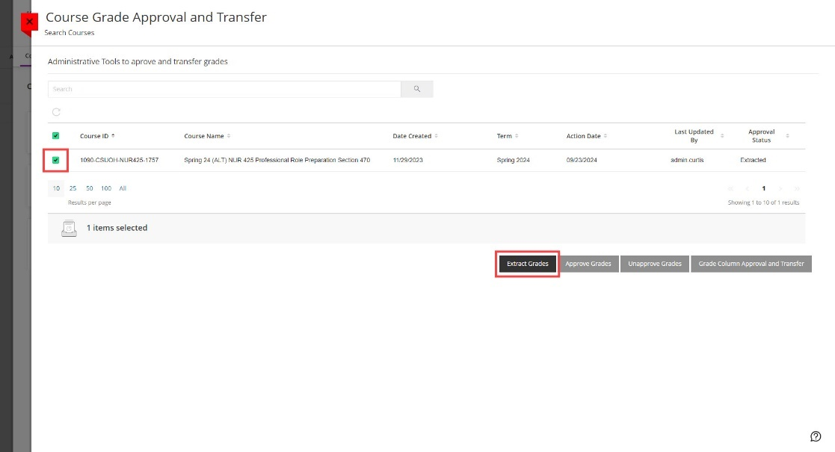

1. You will be asked to confirm the extraction. Click **OK**. Once extracted, grades are sent to CampusNet.

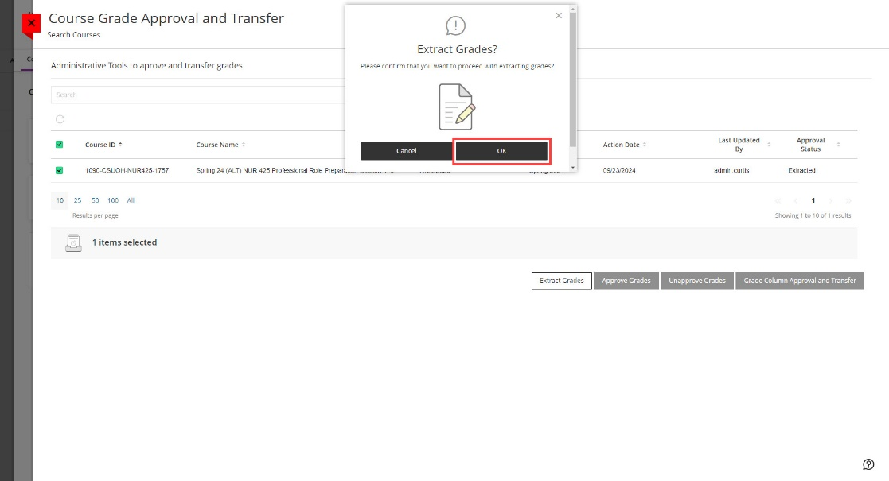

1. You will receive a green confirmation message in Blackboard once the extraction process is complete.

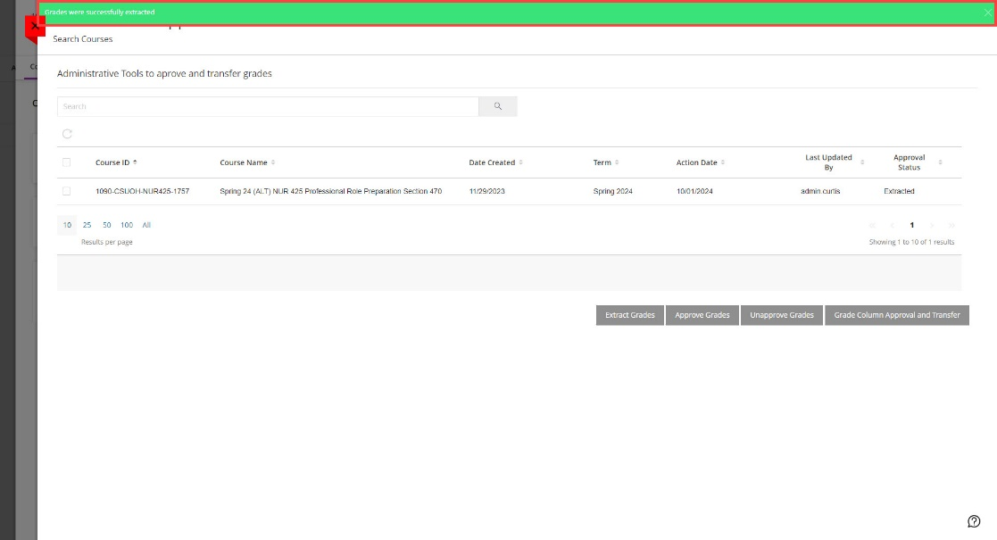

## Import Blackboard Ultra Grades into CampusNet

Now that the grades have been successfully extracted in Blackboard Ultra, you can now go into CampusNet to import them.

1. Log into [CampusNet](https://campusnet.csuohio.edu/) with your CSU ID and password.
2. Click on the **Instructor** tab.
3. Click on the dropdown and select the semester and type you are entering grades for and click **Continue**.

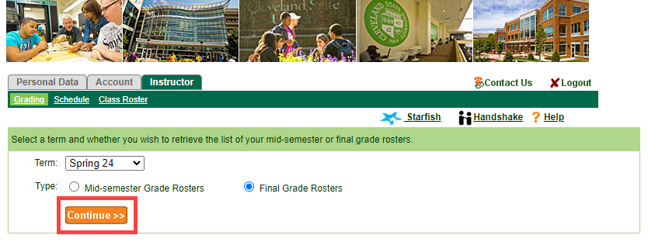

1. Click the **Open** button to the left of the course you would like to import the grades for.

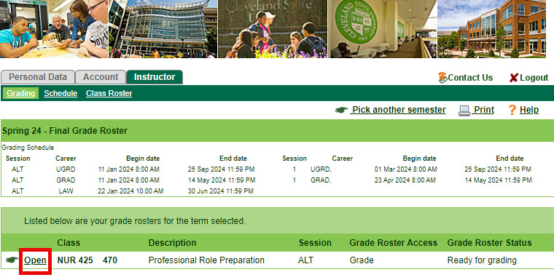

1. You will see a new button labeled **Import grades from Blackboard**. Click this button.

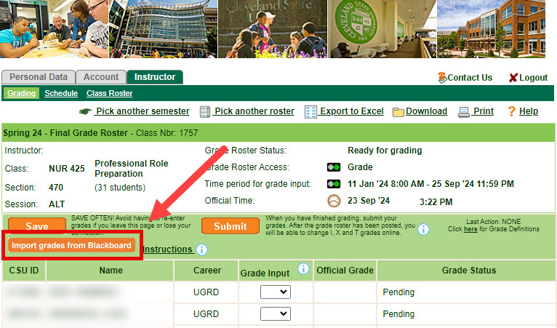

1. You will see the following prompt before grades are imported. This message is to inform you that any grade information that has been already entered will be overlaid. Click **OK**.

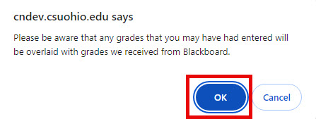

1. You will see another message stating how many grades were imported successfully. Click **OK**.

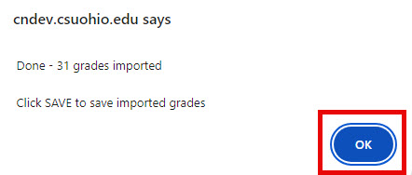

1. You will now see the imported grades under the **Grade Input** column.

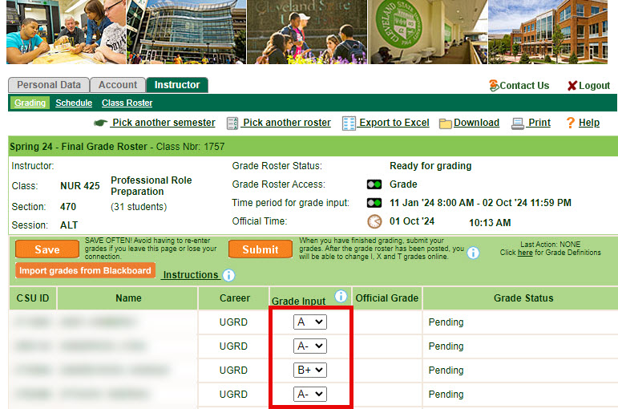

1. Click the orange **Save** button.

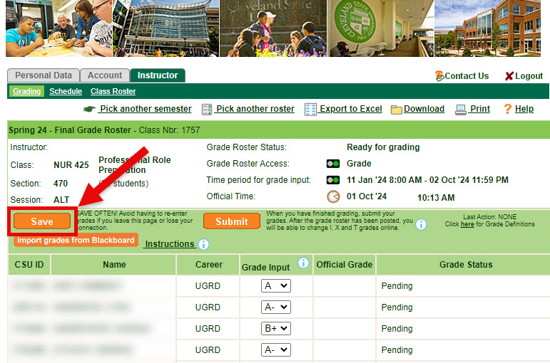

1. Once all the grades have been imported and thoroughly reviewed for accuracy, you are ready to **Submit** the grades. Once you **Submit**, importing grade from Blackboard is no longer available. Click the orange **Submit** to finalize grading for this course.

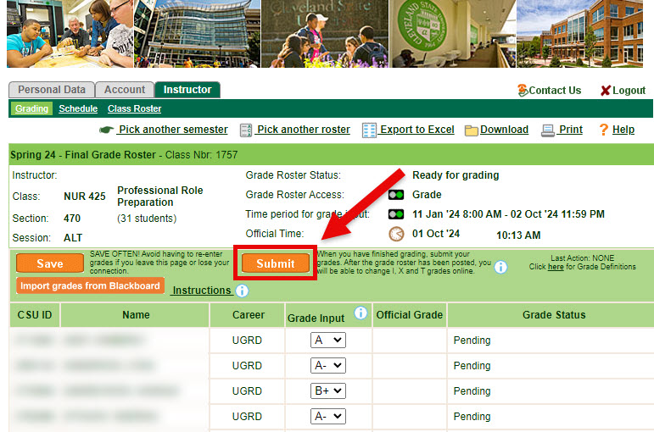

## Possible Errors

* If your Overall Grade column is not reflective of your grades, ensure that all grades are **Posted**. Grades that have not yet been posted are not included in the **Overall Grade**.
* If you receive a red error (**An error occurred while extracting grades**) when attempting to extract grades, this indicates that **Overall Grade** has not been configured. Please refer back to the instructions on Set up Your Overall Grade Column in Blackboard Ultra.
  + 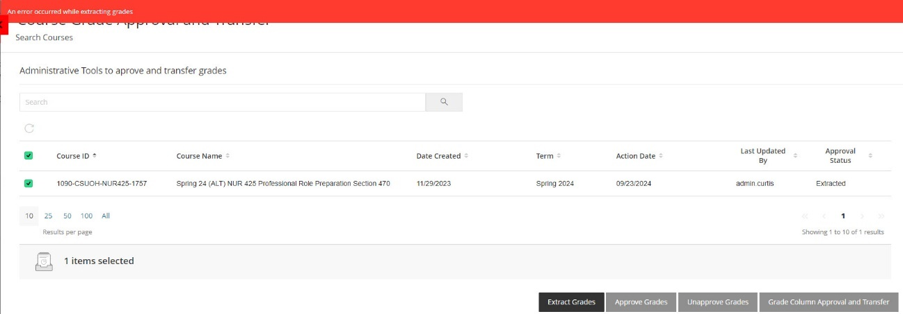
* If you do not set the **Grade Schema** for **Overall Grade** to be **Letter** and attempt to send a numerical value, CampusNet will warn you that the value is not allowed and will not import them until the schema has been set to **Letter** for that column in Blackboard.

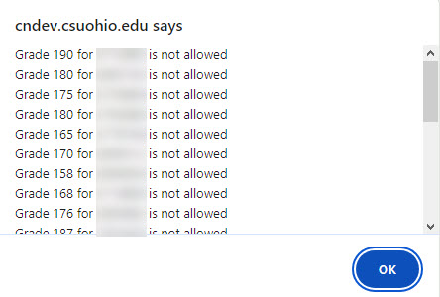

* If you are teaching a graduate level (or combined undergraduate and graduate) course and did not adjust the Grading Schema to remove the C+ row, CampusNet will provide an error for any graduate student who receives a C+ and just that grade will not import. All other grades will successfully import.