Converting your Original Course to Ultra

Instructor Choice: Beginning in Summer 2025
Beginning Summer 2025, CSU instructors can use "Instructor Choice" to choose between Blackboard Original or Blackboard Ultra. The preview feature allows instructors to see the course as an Ultra course before making the decision to move to Ultra. Instructors can also exit the preview and decide to go back to the Original experience.
If you have a previously taught Ultra course shell, or an Ultra development shell, choose Ultra for your experience and then copy in your content (see step 3).
- Do not change the course experience once you have started teaching a course.
- Once a course is upgraded, it can only use the Ultra experience.
- Do not directly convert a previously taught course from Original to Ultra, as doing so will impact student submissions from the course. Instead, start fresh and use only your Summer 2025 course (or a development course that has no student enrollments).
There are two ways to switch from a Blackboard Original course to a Blackboard Ultra course:
- The first is when you open an Original course for the first time, you will be presented with a popup and allows you to immediately convert the course to Blackboard Ultra or remain in Blackboard Original.

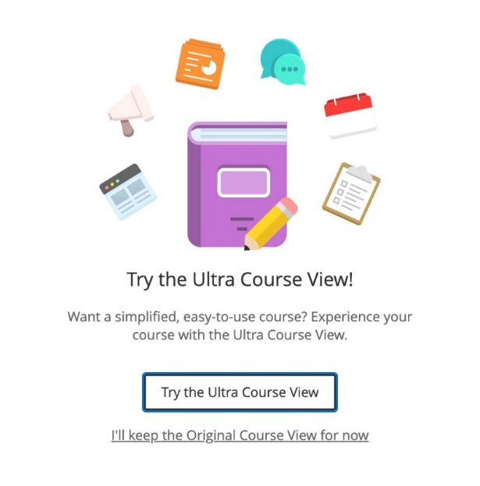
- The second way to preview your course as an Ultra course is to set your Original course to the "Unavailable" status (the default state indicated by the red padlock). You will see the Ultra Preview icon next to the student preview icon. Original courses with an available status will not show this icon.

Once converted to Blackboard Ultra, the course is in a “preview” state. In this state, any changes that you make will not be retained if you switch back to Blackboard Original. If you fully commit to Blackboard Ultra, all of the changes will be saved. The ability to go back and forth between experiences is located at the bottom of the page.
Please note: Once a course has been committed to Blackboard Ultra by clicking the Use the Ultra Course button, you will no longer have the option to switch back to Blackboard Original.

Start with the CSU Template
We revamped the CSU Template for the Ultra experience. Start with this template prior to building a course, OR before copying content in from a previous course. Fill out the request form to have the CSU Template added to your course.
From your Ultra course shell, you can copy content from a previous course. Copy the entire course or specific portions of the course.

Copy Content From a Previous Course
In Blackboard Ultra, the copy process is initiated in the new course, so you are pulling in content from previous courses. The new copy process also allows for performing granular copies and the ability to bring in only the content needed is now possible.
Additionally, you can bring content in from multiple courses using a single copy.
To initiate a copy in your new Ultra course, either click on the three dots > Copy Content to bring content into the course at the bottom of the Content page or click on the plus sign > Copy Content to place it in the exact location of your choosing.
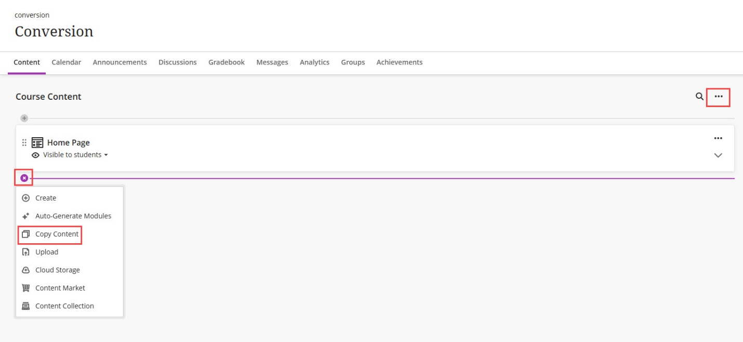
On the copy screen, use the checkbox to the left of a course name to copy the entire contents of the course. One or more boxes can be selected and the list of content being copied will populate in the menu on the right. Click Start Copy to begin the copy process.
Note: Please be patient. The copy process may take some time. You will be notified via email once the process is complete.
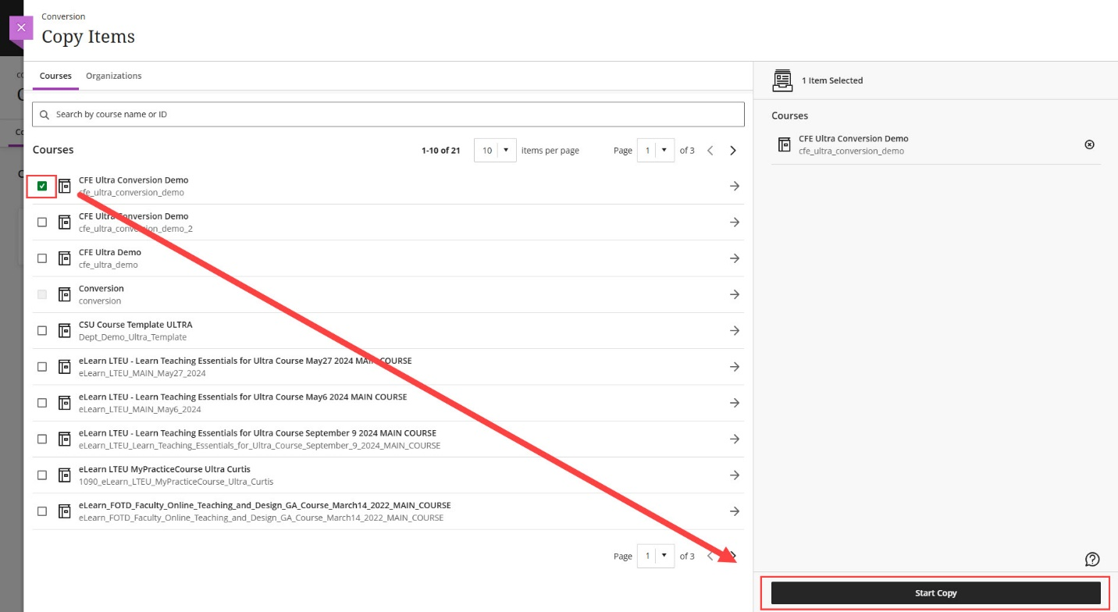
If you would like a more granular copy, click on the arrow to the right of the course name. This will bring up a structure of the course and allow you to pick and choose the items you are interested in copying. You can select as many items from a single course or multiple courses. All of the content added to the copy will populate in the list on the right. Once all the items have been added, click Start Copy to being the copy process.
Note: Please be patient. The copy process may take some time. You will be notified via email once the process is complete.
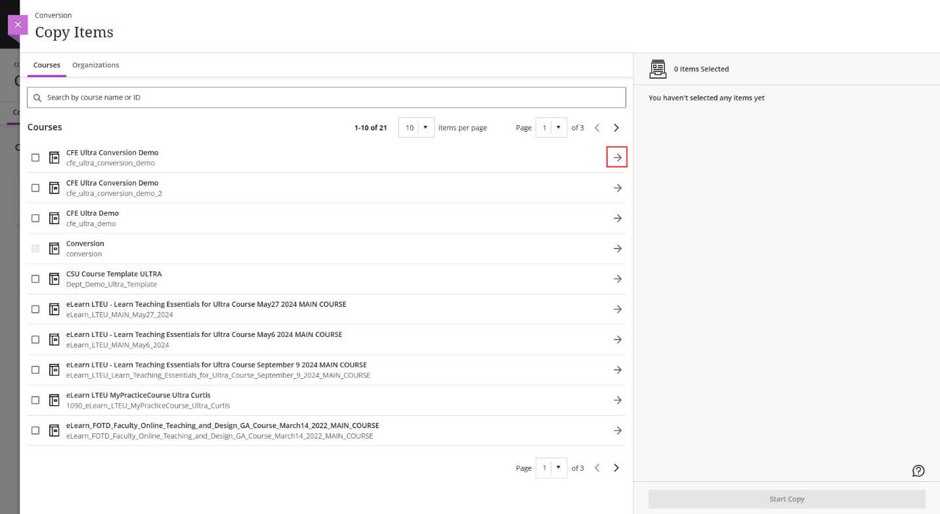
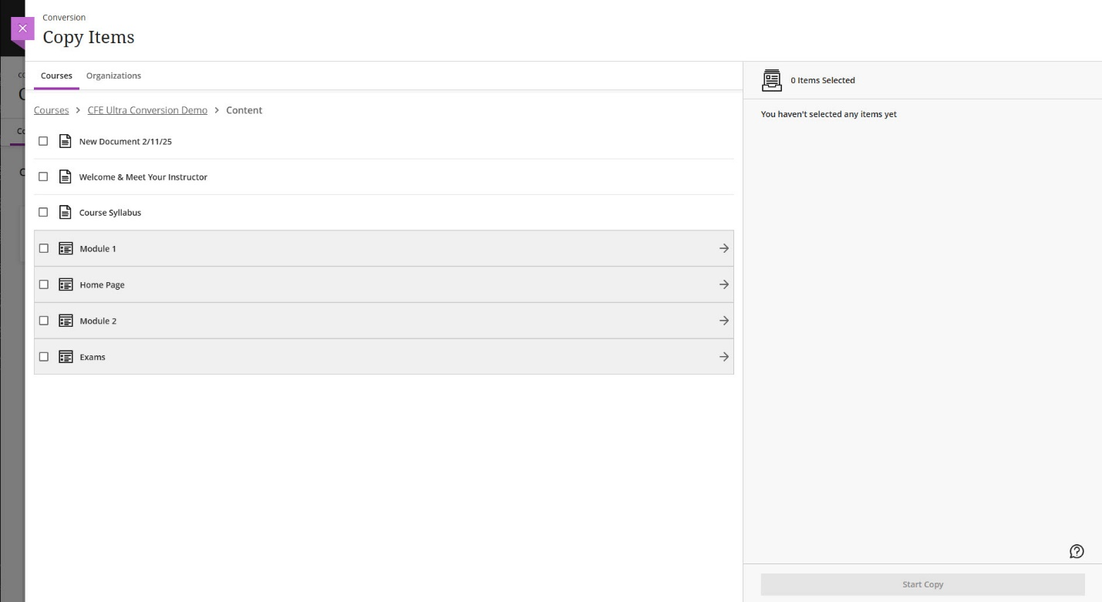

A few differences in Ultra
There are no Blogs and Wikis tools in Ultra. If you would like to use either of these tools, it is recommended that you use the Microsoft Teams integration with Ultra to use similar tools on that platform, while keeping everything accessible from your Blackboard Ultra course.
Folder depth - Blackboard Ultra only supports folder depth of two levels. If you had nested folders beyond two levels in content area in your original course, you will now likely see that content included in the parent folder/module in your Ultra course.

Once your copy is complete
- Review course structure and organization.
- Review links throughout your course and in announcements.
- Make content available/unavailable to students according to your preferences (NOTE: during the copy process, all content defaults to unavailable to students until you make it available). You can use the batch edit feature to make a lot of content available quickly.
- Set up due dates
- Set up your course's overall grade in the gradebook to access enhanced analytics related to course activity and set up alerts to receive and send activity stream notifications when students do not meet specified criteria.

Blackboard Convertible Items
The following features should convert from your Original Course to your Ultra course with little to no disruption:
- Announcements
- Assignments
- Blank Pages
- Content Areas
- Content Folders
- Content Packages (SCORM)
- Course Banner
- Course Menu Blank Pages
- Course Menu Web Links
- Discussion Forums and Threads
- Files
- Flickr Mashups
- Goals
- Grade Center
- Categories
- Grade Schemas
- Group Sets
- Items
- Journals (Note: Journals that aren't linked within a content area are not converted)
- Learning Modules
- Lesson Plans
- Multimedia: Audio, Image, and Video
- Rich Content Editor: Styling, Fonts, and Font Sizes
- Question Pools
- Question Sets
- Question Types
- Calculated Formula
- Calculated Numeric
- Either/Or
- Essay
- Fill in multiple blanks
- Fill in the blank
- Hotspot
- Matching
- Multiple Answer
- Multiple Choice
- Short Answer
- True/False
- Random Blocks
- Rubrics
- Surveys
- Tests
- Web Links

